Title | Guidelines on how to start an enterprise
Keywords (meta tag) | Entrepreneurship, Business Management, Business Plan, Finance, Business Idea
Provided by | IDP European Consultants
Language | ENG
Area | Please select one or more of the following:  Cultural Section  (X) Entrepreneurship section
Objectives / goals / learning outcomes
- Get in touch with basic definitions of Entrepreneurship
- Understand the conceptual differences between Entrepreneurship and Management
- Framework the assumptions of a Business Idea
- Learn and consolidate some essential of Strategic Competitiveness
- Approach to Business and Financial Planning
Description
The following Module consists of a very brief introduction to the essentials of Entrepreneurship. We decided to focus on the main theoretical assumptions that define the entrepreneurial framework for young aspiring entrepreneurs with little knowledge of management and business in general.
In doing so we highlighted the definition entrepreneurship, both from an academic and more operative perspective; the formal distinctions between entrepreneurs and managers; the basics of a Business Idea; few important notions of Business Competitiveness and Strategic Management like “value equation”, “4Ps of Marketing” and “Business Model”, plus a general overview on Business and Financial Planning for funding opportunities.
Contents arranged in 3 levels
Module name: Guidelines on how to start an Enterprise
- Unit 1 – Entrepreneurship: Seeking a Definition
When it comes to Entrepreneurship definition, all possible contributions can be traced back to two main theoretical strands:
- The Economic definition – which gathers Juridical, Anthropological and Sociological contributions
- The Managerial definition – much more aligned to a practitioner and business perspective
For further references on the topic:
- What is Entrepreneurship?
- The role of different theories in explaining entrepreneurship
- Defining Entrepreneurial Activity
- The Concept of Entrepreneurship; in pursuit of a Universally Acceptable Definition
- The Economic Perspective
According to Economic and Social Science literature, Entrepreneurship consists in creating and running a new business with the aim to generate an economic return (profit).
The entrepreneurs exploit tangible and intangible resources to transform production inputs into valuable products and services intended for market consumption.
Following the interpretation of these theories, Entrepreneurship is a typical low risk averse activity promoted by subjects (entrepreneurs) in which prevail the so called “Animal Spirits” – as stated by the great English economist J. M. Keynes, formally recognised as the father of modern Macroeconomics.
Animal Spirits are humoral feelings that motivate entrepreneurial initiatives and nurture an overoptimistic spirit in the vision of the rising entrepreneurs.
- The Managerial Perspective
Entrepreneurs are individuals with a seeking-opportunity mindset that deploy, develop, test and trade the necessary solutions for the exploitation an unsatisfied need.
Citing the great management theorist J. A. Schumpeter, entrepreneurs are “creative destructors” that boost Innovation and social well-being benefiting the overall society and its citizens.
- Management vs Entrepreneurship
Nowadays, theorists concluded that the differences between Entrepreneurship and Management stands on mere but very important formal factors:
- Firm’s ownership (the possession of the capital)
- Risk assumption
- Responsibility for the financial and economical sustainability of the business
These three points are the conceptual pillars that formally distinguish the entrepreneur from its managerial team.
From a broader and more substantial/practical perspective, managers and entrepreneurs share a lot in common, specifically when it comes to the definition of a long-turn strategic vision and a competitive plan.
However, It is not wrong to say that managers – regardless of their executive autonomy – are always bounded to perform and fulfil the firm ownership’s will and to enable its long-term priorities.
- Entrepreneurial Management
Very recently, a trending topic among academics and practitioners is the so defined “entrepreneurial management” framework – which consists in a sort of synthesis between the two roles.
More specifically, according to Robert Price – Executive Director of the Global Entrepreneurship Institute – entrepreneurial management is:
The practice of taking entrepreneurial knowledge and utilizing it for increasing the effectiveness of new business venturing as well as small- and medium-sized businesses [that moment of the business lifecycle in which the figure of the entrepreneur and the manger coincide in one person]
Further reading: WHAT IS ENTREPRENEURIAL MANAGEMENT?
- Unit 2 – The Business Idea
- The transition from theory to practice
Any idea that might turn into a profitable Business is commonly defined as “Business Idea”.
According to entrepreneurial literature, a Business Idea satisfies market needs that are not yet: or fully matched by competitors, or not even still known and explored.
Consistently, the innovativeness of a Business Idea is greatly testifiedby:
- What kind of need is addressed?
- How it is addressed?
In other words, the great majority of Business Idea and related enterprises can be all reconnected to:
- Better solutions applied to well-known needs – taking advantage from the existing ones
- Completely new solutions applied to well-known needs – disruptive solutions that leverages, for instance, on new technologies
- New solutions that exploit unknown / unexplored needs (dormant needs)
- Existing solutions that are reinvested in new markets but with a different intended use
Most of the times, coming up with a Business Ideas seems much more like a “brainwave” moment rather than a mechanical and highly energy-consuming process.
The best way to trigger such opportunity is by stimulating your creativity:
- Start to pay great attention to what you see in the surrounding environment
- Try to read more than you ever did and educate yourself
- Do not be afraid to question your beliefs neither to wear the other’ shoes
- Take note of your thoughts and order them by relevance
- Do not take anything for granted, even what may seem trivial
- Train your active listening and critical reasoning
The genesis of an Idea occurs relatively spontaneously; the real challenge comes with the nurturing of the Idea and its transition into the “Business Status”.
You might get to hundreds of conclusions but only a very small percentage of them is feasible from an entrepreneurial perspective and even less are actually profitable.
These proportion are absolutely true and empirically observed in reality.
- The Innovation Funnel
The Innovation Funnell
In 1992, few scholars observed that out of a very large number innovation and entrepreneurial idea, only a handful remained “alive” throughout the development route and entered the commercial phase.
Hundreds and hundreds of prototypes and ideas have been abandoned halfway because not convertible into commercial and profitable products / services.
Is your idea reliable and strong enough to pass through all funnel’ stages?
Most likely, you will never know as long as there is still no concrete evidence of your rising firm. Anyway, there are few things that might help you to reduce such uncertainty.
A recommended exercise is to “stress-test” your Business Idea so to self-evaluate from the very beginning its resilience coefficient.
Stress-testing is a very consuming activities because it implies the full evaluation of all factors that directly impact not only the profitability of your business, but its own feasibility.
In doing so, try to be as unbiased as possible and make sure to consider all possible disruptive factors – both internal and external.
Challenge the credibility of your idea and pretend to wear an investor’ shoes:
- Would you put your money – plus trust and reputation – in your idea?
- Would you still fell in love with it if it wasn’t yours?
- Are you sure there are not any other more valuable options?
- Etc.
- Unit 3 – Basics of Business Competitiveness
Let’s suppose that, after leading your stress-test analysis, you have finally come to the conclusion that your idea is at least feasible: what now?
There are two further things to be addresses:
- The potential sources of your competitive advantage – what allows your offer to stand out from the competitors
- The Business Model – how business functions will help to generate revenue and turn profit
- The overall structure of your value equation – how customers and final user of you product/service perceive the benefits of your offers
- Competitive Advantage
Michael Porter, the most famous business strategy theorist, identified three main types of competitive advantage:
- Cost leadership strategy – when firms are able to conduct the production processes at lower costs than the others, without compromising the quality of the final output
- Differential Strategy – the final output stands out not because of its cheaper price but thanks to its intrinsic characteristics. Such strategy is perfectly consistent with product/services at high innovative content, which required intense R&D efforts
- Focus Strategy – the business canalise its effort towards a very selected market with high profitability potential
Your preference among the three will essentially depend on what kind of market you are going to operate in and what is the average customer profile that within it.
Generally speaking, for fast-moving consumer goods the most consistent choice implies a Cost Strategy; while Focus and Differentiation are much more recommendable when dealing with more sophisticated market (i.e. luxury products).
Consistency between strategy and market is a key element of success: you must always make sure to meet the exact expectations of your reference market by communication the right things in the right way.
- Business Model
The business model describes the logical assumptions that guide and orientate the organisation in its mission to pursuit a profit.
In other words, it describes the solutions and methodologies invested by the firm to organise and plan strategies, resources, roles, responsibilities and objectives.
The design of the business model is a crucial step at firm’s inceptions because it unavoidably impacts its ability to generate profits and support its future financial sustainability.
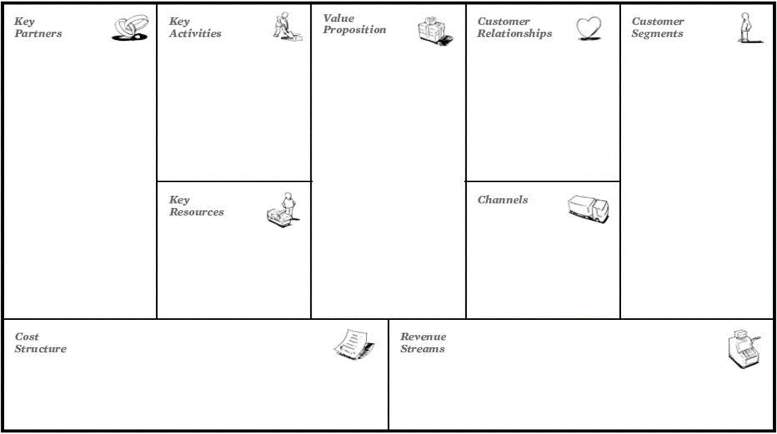

The image just shown is a model from the first half of the last decade known as the “Business Model Canvas” and it is used to support the aspiring entrepreneurs in the definition of its business model on a self-customised basis.
- The sections must be filled following a very specific order:
- Value Proposition
- Customer Segments
- Channels
- Customer Relationship
- Revenue Streams
- Key Partners
- Key Activities
- Key Resources
- Cost Structure
- Business Model Canvas
According to Marketing Specialists, the value equation that a firm propose to its targets results from fours variables, also known as the “4 Marketing Ps” (or Marketing Mix).
- Price
- Product
- Place (i.e. stores)
- Promotion
Aspiring entrepreneurs need to learn how to balance each variable consistently with the others so to exceed the expectations of their customers.
- Value Equation
More recently, the model has been extended with three others “Ps”:
- Packaging
- Placement
- People
These new ingredients imply a greater ramification of the value equation with a much more intense dependability between variables.
Among all 7Ps, there is no particular hierarchal order: each one of them deserve the same coefficient of attention and scrupulousness throughout every lifecycle of the organisation.
- Unit 4 – Business Planning and Financing
Once that all main assumptions are clear and well-defined, the aspiring entrepreneurs is called to draw up the Business Plan – one of the most important documents that she/he will ever draft in her/his entrepreneurial career.
As the name suggests, the Business Plan is a document that showcase and valorise all key dimensions of the business itself (competitiveness, innovation, etc.).
Its greater purpose is to convince external investors about the profitability and great reliability of both the business idea and the underlie organisation: regardless of the funding entity (banks, super angels and venture capitalists), before mobilising their resources, investors need a tangible/convincing proof that the future gain from their investment will exceed the present outlay
- Business Plan
The best-practices and guidelines to draft an effective Business Plan come from consolidated practices.
The information to highlight is:
- very short presentation of the organisation, its team and the overall Business Idea
- brief presentation of the offer and the strategy pursued to place it on the market (benchmark and competitor’s analysis)
- in-depth market analysis (a summary of the key-points emerged from the 7Ps analysis)
- environmental and social impact of the entrepreneurial initiative
- financial reliability and short-long term revenue streams perspective
- Financial Plan
All information is equally relevant, but at the eyes of an investor there is a piece of data that prevails on the others: the financial and economic capacity of the organisation – especially in the long period.
Aspiring entrepreneurs are called to state all three main documents that disclose the financial and economic stability of their firm:
- Balance Sheet – Assets vs Liabilities
- Income Statement – Revenues vs Expenses
- Cash Flow Statement – Incoming vs Outgoing cash
All information is equally relevant, but at the eyes of an investor there is a piece of data that prevails on the others: the financial and economic capacity of the organisation – especially in the long period.
Aspiring entrepreneurs are called to state all three main documents that disclose the financial and economic stability of their firm:
- Balance Sheet – Assets vs Liabilities
- Income Statement – Revenues vs Expenses
- Cash Flow Statement – Incoming vs Outgoing cash

Socrative Questions (n.3):
- Is creativity important to develop a business idea? And eventually, how to develop creativity?
- What is the Business Model Canvas?
- According to Michael Porter, what are the three main types of competitive advantage?
5 glossary entries
- Entrepreneurship consists in creating and running a new business with the aim to generate an economic return (profit).
- Animal Spirits are humoral feelings that motivate entrepreneurial initiatives
- Cost leadership strategy – when firms are able to conduct the production processes at lower costs than the others, without compromising the quality of the final output.
- Differential Strategy – the final output stands out not because of its cheaper price but thanks to its intrinsic characteristics. Such strategy is perfectly consistent with product/services at high innovative content, which required intense R&D efforts.
- Focus Strategy – the business canalises its effort towards a very selected market with high profitability potential.
Bibliography and Further References
- What is Entrepreneurship?
- The role of different theories in explaining entrepreneurship
- Defining Entrepreneurial Activity
- The Concept of Entrepreneurship; in pursuit of a Universally Acceptable Definition
- WHAT IS ENTREPRENEURIAL MANAGEMENT?
Related Material
Related PPT | All Routes lead to Rome IO3 Guidelines on how to start an Enterprise _ IDP
Reference Link

